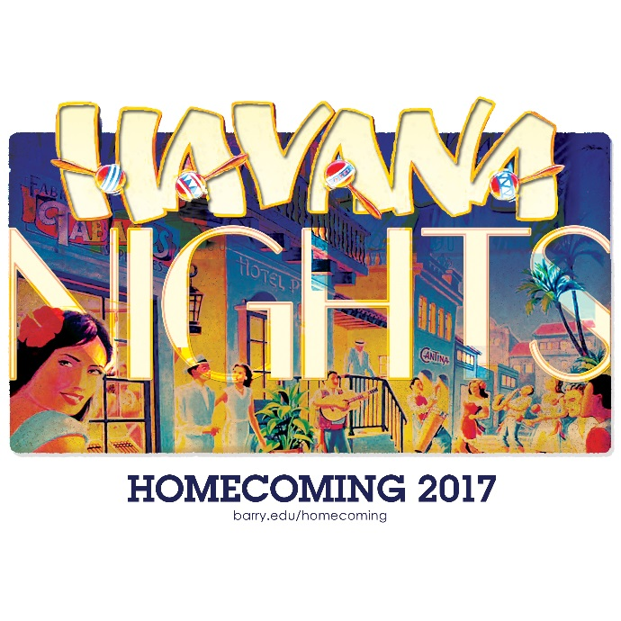

2017 Barry University Homecoming Court
Application and Guidelines

Applications are due by 5pm on Friday, January 27 to front desk of Landon 202 or 202F
Late applications will not be accepted.

Do you have what it takes to represent Barry University? The Homecoming committee is proud to sponsor this contest that recognizes students that embody the spirit of Barry University while striving for the academic achievement, campus involvement, and community service. Make the most of your university experience by applying to become a part of the 2017 Homecoming Court! The finalist for court will be announced during the Homecoming Window Decorating on Sunday, February 5th and the winners of Homecoming Court will be sashed/crowned during the halftime show of the Men’s Basketball game on Saturday, February 11th.

Eligibility:
To apply, you must meet the following criteria:
- Be sponsored by either a Recognized Student Organization or one (1) faculty/staff members
- Must be enrolled as a full time student (12 credit hours).
- Must have a 2.5 cumulative GPA.
- Must be in good academic and conduct standing with the University.

Instructions:
Please print clearly using black ink. Your responses will be reviewed by the selections committee. Your personal statements and information will be used for voting, during announcements at Homecoming activities and other publicity.
A headshot photo must be emailed along with applications to mahayes@barry.edu

Name:
Student ID #:
Barry E-mail Address:
Classification:
Major:
Expected Graduation Date:
Birth Date:
Hometown:
Sponsor(s): | Name of Recognized Student Organization:  President’s Signature: ______________________________________________________________  OR  Faculty/Staff Name: ________________________________________________________________  Signature: ________________________________________________________________________

I hereby authorize the appropriate University departments to release information as to my academic, enrollment and disciplinary standing at Barry University to the Barry University Homecoming Committee in order that they may certify qualifications for candidacy for the 2017 Homecoming Court.

Signature of Applicant: ____________________________________________________ Date: _______________________

FOR OFFICE USE ONLY

GPA _________ Full Time Status _________ Classification _________

Homecoming Court Timeline, Composition and Selection Process

Tuesday, January 10th - Applications are available online and in Center for Student Involvement, Landon 202.

Friday, January 27th by 5PM - Applications due (Refer to deadline on the top of page 1 of application)

Tuesday, January 31st by 5PM –applicants notified if they have been selected for an interview.

Friday, Feb.3rd (4:00-7:00pm) The top six (6) candidates for each category will be interviewed by Barry University Faculty & Staff selections committee to determine the finalists of the 2017 Homecoming Court.

Sunday, Feb. 5th @ 1 p.m. The 2017 Homecoming Court students’ names will be announced at Window Decorating

Monday, Feb.6th – Friday, Feb 10th The 2017 Homecoming Court students’ campaign and encourage students to vote.
*Finalists will review the campaigning rules in person with a member of the Homecoming committee.

Monday, Feb.6th – Friday, Feb 10th All Barry University students may vote for the 2017 Homecoming Court.

Saturday, Feb. 11th The 2017 Homecoming Court sashed/crowned at Women and Men’s basketball game half-time.

Finalists & Homecoming Court Composition
 |  | Finalists | Homecoming Court
Freshman and Sophomore  Prince/Princess | 60 hours or less | 3 male  3 female | 1 male  1 female
Junior and Senior  King/ Queen | 61 hours or more | 3 male  3 female | 1 male  1 female
34 Second Round
Scants Interviewed
Selection Committee
The Selection Committee strives to select Barry University Faculty, Staff and Alumni who are good judges of Barry University student academic achievement, campus involvement and representation for the University. While students may be familiar to some judges, we ask that judges treat each applicant on their own merit as a representative of Barry University. Judges will score applicants in four main categories:

Contributes to campus life
Quality involvement in student organizations
Participates in activities that enhance BARRY UNIVERSITY
Committed to the Barry University Commitment to Community (see below)

Service
Organizes and/or participates in service for Barry University or the surrounding community

Strength of application
Overall impression of the applicant and totality of the application

Overall good ambassador for BARRY UNIVERSITY
Demonstrate through application and interview a genuine affinity and pride for Barry University
Willing to contribute his/her time to improve campus life
Knowledge of Barry University traditions and history

Activities and Deadlines

Mandatory appearances for the 2017 Barry University Homecoming Court take place at the following dates and times.*

Sunday February 5th: Window Decorating Noon – 5 pm Landon Courtyard (Inside Windows) – Decorating one Window
Monday February 6th: Golf Cart Decorating Noon– 5 pm – Starting in Landon Courtyard- Decorate a Golf Cart
Golf Cart Parade 7 pm – Leading to Dominican
Kick off Bonfire 7:30 pm – 11 pm – Dominican Lawn- Announcement of Court is officially made.
Wednesday February 8th: Buc Lip Sync @ 8 p.m. – Staff Lot Mainstage – Act as MCs and Special Judges
Thursday February 9th: Salsa Night @ 8 p.m. – 10 p.m. – Andreas 111 & 112 – Participate in Event
Friday February 10th : Homecoming Dance 9 pm - Midnight– Andreas 111 & 112 and Courtyard- Final Chance for Voting
Saturday February 11: Basketball Game (announcement of court made between games) TBD

Future Appearances Required by the Homecoming Court Winners:
- Student Affairs Awards Banquet held in April

*Tentative and subject to change. You will be given advanced warning of any changes are made

APPLICTATION FOR HOMECOMING COURT 2017

List the Recognized Student Organizations or programs you are most involved in while a student Barry University | Include Leadership Positions | Semester(s)/Year(s)

List any community individual service projects, organization, activities, professional or civic organizations most involved in while attending Barry University. Do not list community service done through campus organizations to which you belong. | Semester(s)/Year(s)

List any honors, awards, or scholarships while attending Barry University | Semester(s)/Year(s)

List any employment or internships while attending Barry University | Semester(s)/Year(s)

Based on your experience at Barry University, what advice would you give an incoming freshman?
____________________________________________________________________________________________________________
____________________________________________________________________________________________________________
____________________________________________________________________________________________________________
____________________________________________________________________________________________________________

What would it mean to you to be part of the 2017 Barry University Homecoming Court?
____________________________________________________________________________________________________________
____________________________________________________________________________________________________________
____________________________________________________________________________________________________________
____________________________________________________________________________________________________________

Describe your best qualities to serving in representing Barry University.
____________________________________________________________________________________________________________
____________________________________________________________________________________________________________
____________________________________________________________________________________________________________
____________________________________________________________________________________________________________

How do you promote being a Barry Buccaneer?
____________________________________________________________________________________________________________
____________________________________________________________________________________________________________
____________________________________________________________________________________________________________
____________________________________________________________________________________________________________

What is Barry Pride?
____________________________________________________________________________________________________________
____________________________________________________________________________________________________________
____________________________________________________________________________________________________________
____________________________________________________________________________________________________________

