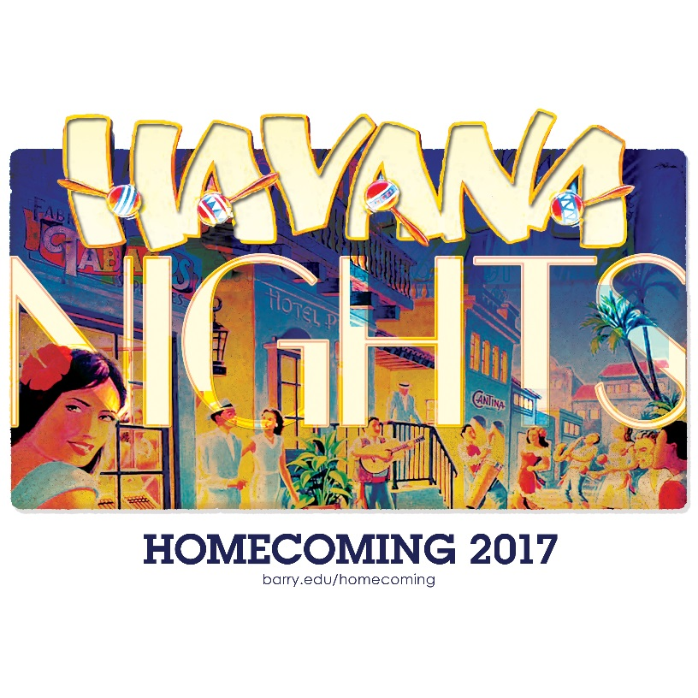

CUP REGISTRATION FORM
Instructions: Team Registration forms are due to the front desk of Landon 108 or 202 no later than 5pm on Friday, January 20th, 2017. Contact 305-899-3960 with any questions. Incomplete registrations will not be accepted. Team names may be subject to change at the discretion of the university.

Team: _______________________________________________________________
Team Captain Name: __________________________________________________________________
Cell Phone No.: ______________________________________________________________________
Barry Email Address: _________________________________________________________________
List names of all team members (minimum 5). If you are a Registered or Recognized Club/Org and want to use updated Spring ’16 roster submitted to SOC Check: Yes No
 | Full Name | Phone # | ID Number
1  Team Captain | a
2 | a
3 | a
4 | a
5 | a
6 | a
7 | a
8 | a
9 | a
10 | a

Team Captain’s Commitment
The team captain is responsible for ensuring that his/her team members are fully aware of the event rules and abide by them at all times. All communication will be sent via Barry University email.

____________________________________________________ __________________________________________
Team Captains Signature Date
OFFICE USE ONLY
Received on: _____ / _____ / _____ Staff Member Initials: ________

GENERAL RULES
Each team must have a minimum 8 Barry students. Each person may participate on no more than 1 team. Teams must participate in all required events to be eligible to win the Homecoming Cup.

Waivers will need to be signed by each player prior to each competition.

POINT SYSTEM
Each event will have a scoring system attached to their rules and regulations. Bonus points may apply to certain events. Be sure to read through the rules and regulations and contact a member of the Center for Student Involvement with any questions regarding the Homecoming Cup.

WEEK CALENDAR OF EVENTS
See which events are mandatory to be involved with the 2017 Homecoming Cup. The first place winner of the 2017 Homecoming Cup will win a $1000 event sponsored by CSI, 2nd place will win a $500 event sponsored by CSI, and 3rd place will win a $250 event sponsored by CSI.

Sunday [February 5, 2016]

Window Decorating | 1:00pm | Landon Courtyard
Clubs, Organizations and Student Groups will be able to register and reserve a window to decorate facing the Landon Courtyard. This is an opportunity for Clubs and Organizations to show their support for Homecoming while promoting their presence on campus and earn points toward the Homecoming Cup. A panel of Judges will select 1st, 2nd and 3rd place winners. This event is a part of the Homecoming Cup Competition.

Participation is Mandatory to be eligible for Homecoming Cup 2017

 | Full Name | Phone # | ID Number
1 | a
2 | a
3 | a
4 | a
5 | a
6 | a
7 | a
8 | a
9 | a
10 | a

Monday [February 6, 2017]

Golf Cart Parade | 7:00pm | Landon Courtyard
The Golf cart parade will consist of groups of students, faculty and/or staff decorating golf carts in accordance with this year’s theme: “Havana Nights”. Upon completion of the decoration process, the groups will parade the golf carts to the Dominican Lawn to kick off the Homecoming Bonfire. The link to register is https://www.surveymonkey.com/r/FFNFC3H Please be mindful that space is limited. Please note there is a maximum of six (6) people who can help with the Golf Cart decorating and parade.

Participation is mandatory for Homecoming Cup. Please register for the Golf Cart Parade no later than January 20, 2017 to ensure you have a Golf Cart for the parade

 | Full Name | Phone # | ID Number
1 | a
2 | a
3 | a
4 | a
5 | a
6 | a

Bonfire | 9:00pm | Dominican Lawn
The Homecoming Bonfire will be a gathering of students in celebration of the kick off to the 2017 Barry University Homecoming! There will be music, novelties, student performances, introductions of our Homecoming court as well as Men’s and Women’s Basketball teams. This is a great way to come together as a community in preparation for the biggest week of the year!

Note: Attendance is optional, but recommended.

Tuesday [February 7, 2017]

Festival of Nations | 12:00pm | Landon Parking Lot Main Stage
Festival of Nations is one of Barry University’s largest cultural event and has been part of Barry’s tradition since 1995. Showcasing the richness and diversity of our international culture on campus displayed, the event includes student-sponsored country booths, food, music and dance, games, performances, and other exciting activities.

Bonus points will be awarded for groups that have a booth at Festival of Nations. Please contact IMP for more information.

Wednesday [February 8, 2017]

Buccaneer Boat Races | 3:00pm | Penafort Pool
Clubs, Organizations and Student Groups can test their ship making skills. Each registered team will be given a list of approved building materials and starting supplies a week prior to the race. They will need to build a sea worthy vessel that will make it the length of the pool. Each team will be timed and the top three times will be awarded points toward the Homecoming Cup.

Participation is mandatory for Homecoming Cup. Please list the four (4) contestants that will represent your organization
 | Full Name | Phone # | ID Number
1 | a
2 | a
3 | a
4 | a

.

Havana Nights Baseball Spirit Event | 6:00pm | Baseball Field
In the spirit of the Cuban homecoming theme, come out to a night of Baseball and school spirit. Games, give-a-ways, and food will be provided.
Bonus points will be provided for having three (3) volunteers attend the Baseball Spirit Event

 | Full Name | Phone # | ID Number
1 | a
2 | a
3 | a

Bucs Lip Sync | 10:00pm-12:00am | Landon Parking Lot Main Stage
Come enjoy groups lip sync to some of the most popular Salsa music around. The night will be filled with Latino flair and dancing that will be sure to entertain the masses.

Participation is mandatory for Homecoming Cup. Please list the a minimum of three (3) a maximum of ten (10) contestants that will represent your organization
 | Full Name | Phone # | ID Number
1 | a
2 | a
3 | a
4 | a
5
6
7
8
9
10

Thursday [February 9, 2017]

Barry Amazing Race | 9 a.m. - 3:00pm | Various Locations
Photo Scavenger Hunt
Friday is where Clubs, Organizations and Student Groups can get photos for the scavenger hunt. If you are lucky to snap a shot with Bucky, a homecoming court member, or someone dressed up in a homecoming t-shirt; you can rack up more Homecoming Cup Points.

Participation is mandatory for Homecoming Cup. Please list the a minimum of three (3) a maximum of eight (8) contestants that will represent your organization
 | Full Name | Phone # | ID Number
1 | a
2 | a
3 | a
4 | a
5
6
7
8
9
10

Salsa Night | 8:00pm | Andreas 111 & 112
Come learn some awesome salsa moves, enjoy some free food, and learn more about Cuban culture!

Bonus points will be provided for having three (3) volunteers attend the Baseball Spirit Event

 | Full Name | Phone # | ID Number
1 | a
2 | a
3 | a

Friday [February 10, 2017]

SGA Powder Puff Football Game | 3:30pm | Intramural Fields
The Student Government Association turns the table on traditional football standards! In this classic competition, the females compete in a flag football tournament while being coached and cheered on by their male classmates. Always full of spectacular action, The 2016 SGA Powder Puff Game will be sure to be an event full of action packed competition!

Note: Attendance is optional, but recommended.

Homecoming Dance | 9:00pm | Andreas 111-112
Come enjoy an evening of Cuban flair! Enjoy cocktail hour from 9:00pm – 10:00pm. There will be hors d’oeuvres and a variety of refreshments including a midnight toast! Dress to impress as this event is semi-formal. Attendance is free this year.

Bonus points will be provided for having three (3) volunteers attend the Baseball Spirit Event

 | Full Name | Phone # | ID Number
1 | a
2 | a
3 | a

Saturday [February 11, 2017]

Bucky Fest and BBQ | 11:00am | TBD

